

UNICEF

Names : Annisa Kurnia Putri (1820010033)

Stephanie Miranda sibarani (1820010204)

Class : 2SC

CEP CCIT

FAKULTAS TEKNIK UNIVERSITAS INDONESIA

2019

**Developed by**

1. **Annisa Kurnia Putri**



**PROJECT ON**

*UNICEF*

**MANUP**

Batch Code : 2sc

Start Date : september 1, 2020   
End Date : september 7, 20120

Name of Faculty :

Names of Developer :

1. Annisa Kurnia Putri

Date of Submission: September 7 , 2020

**CERTIFICATE**

This is to certify that this report titled “Unicef” embodies the original work done by Annisa Kurnia Putri and Stephanie Miranda. Project in partial fulfillment of their course requirement at NIIT.

Coordinator:



**ACKNOWLEDGEMENT**

Developers have benefited a lot from the feedback and suggestions given to us by Mrs. . Developer make this project to fulfill our assignment.

First of all, praises and thanks to Allah SWT that gives the developers all the grace to finish writing the paper entitled “Unicef”.

We are working on this paper from the results of our group collaboration and assistance from several parties. Therefore we thank you for the help of the parties involved. But we realize that this paper is still not perfect in arrangement and the content. Then the writer hopes the criticism from the readers can help the writer in perfecting the next paper. Last but not the least that hopefully, this paper can help the readers to gain more knowledge about Developing Enterprises Information System using Framework.

If the writer made a mistake in writing the Unicef, writer ask for forgive to all readers and audiences.

**SYSTEM ANALYSIS**

**System Summary**:

Unicef is a website for donation that is intended to provide humanitarian assistance add development to children , and also provide donation activities if there is assistance who whants to join as a volunteers.

**DESIGN INTERFACE**

**System Process**:

Homepage

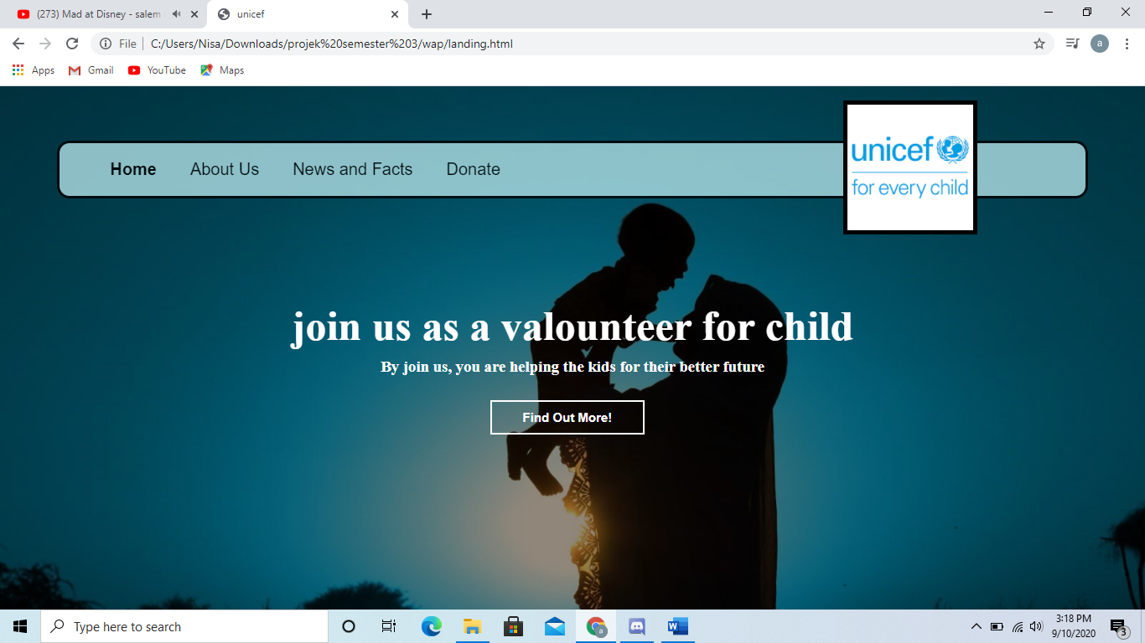

About us

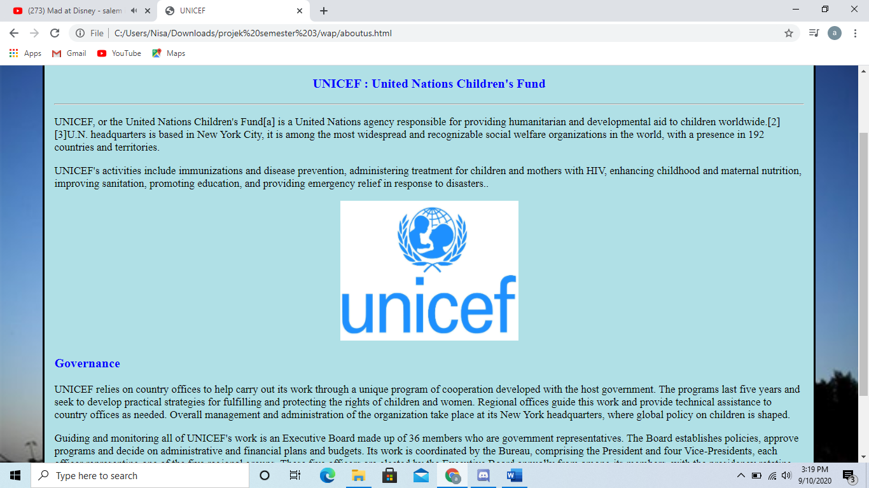

**DESIGN INTERFACE**

News and fact

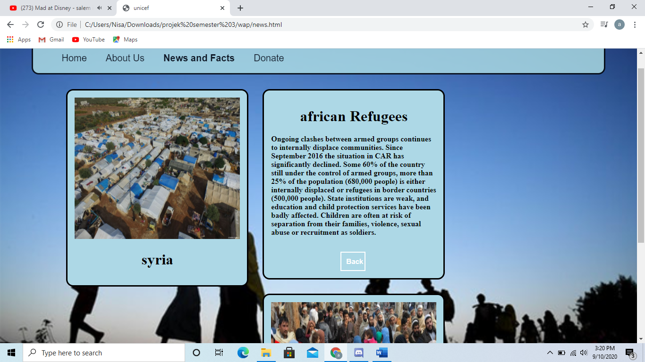

Dontion colum

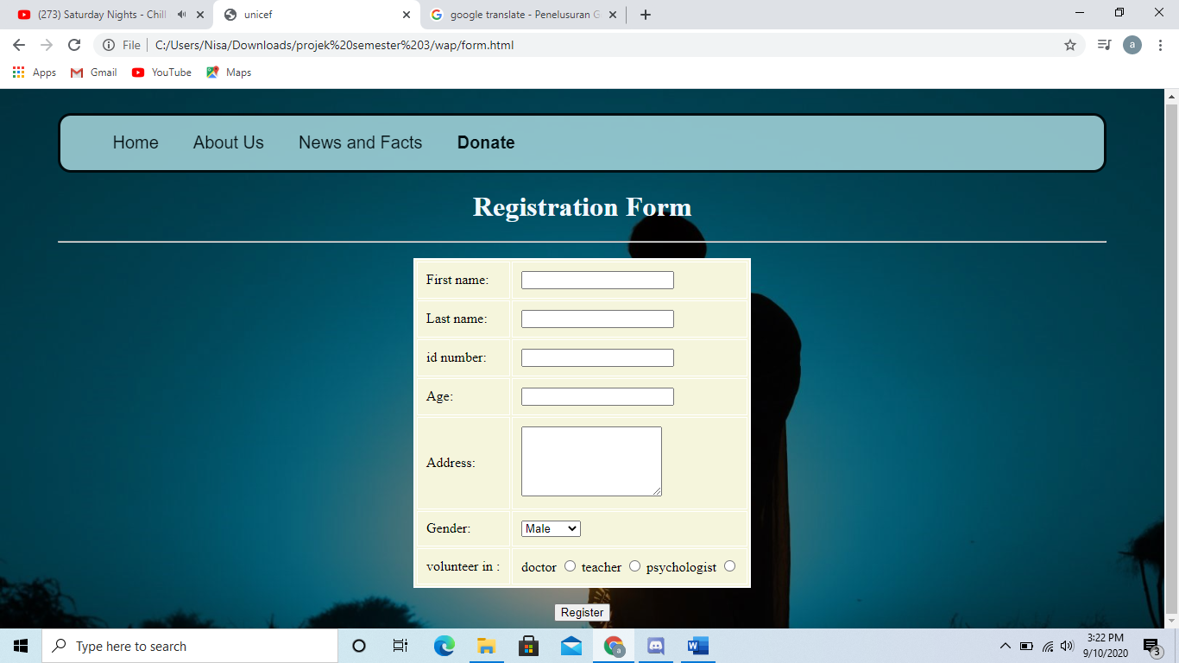

**DESIGN INTERFACE**

Example of Registrasion

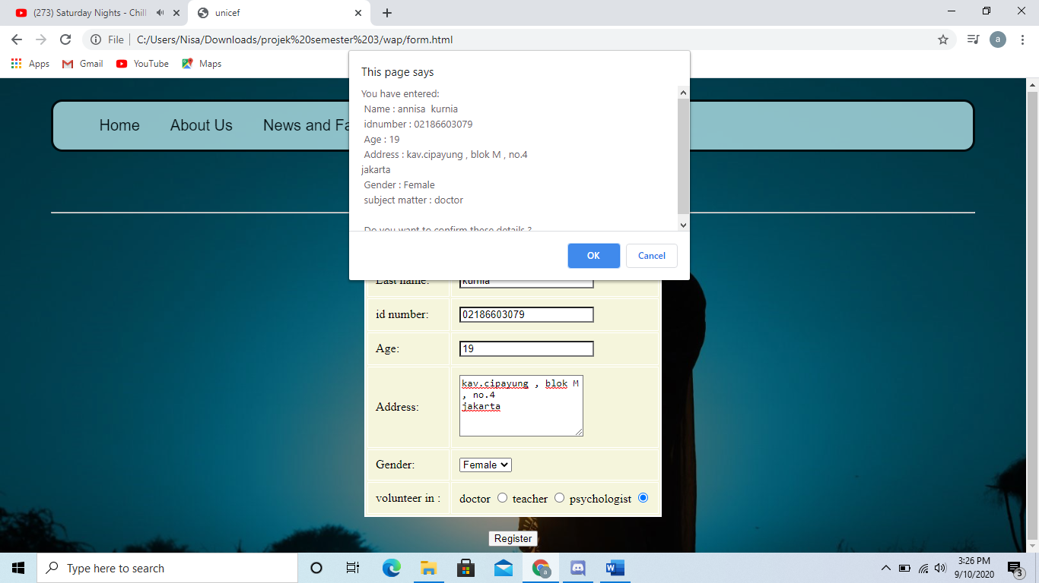

**CONFIGURATION**

**Hardware : Asus Vivobook 14k413ep**

**Operating System : Windows 10 Pro**

**Software :**  HTML 3

|  |  |  |
| --- | --- | --- |
| **PROJECT FILE DETAILS** | | |
| **S.No** | **File Name** | **Remarks** |
| 1. | Login.html | Display sign in page |
| 2. | Aboutus.html | Display about unicef page |
| 3. | Landing.html | Display join us volunteer page |
| 4. | Form.html | Display registration form page |
| 5. | Donate.html | Display about donation page |
| 6. | Abisregist.html | Display registration volunteer page |
| 7. | News.html | Display about donation page |

\

sssssssssss